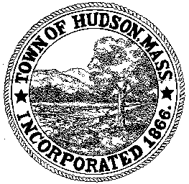

CONSERVATION COMMISSION
78 Main Street, Hudson, MA 01749
(978) 562-2020

Paul Byrne, Chairman W. Minot Wood, Vice Chairman David Esteves, Member

Terrence Joyce, Member Leif Longtine, Member Joseph Rodrigues, Member Al Tashian, Member

Meeting Agenda
August 18, 2011 7:00 P.M.

- Preliminaries
  - Open Meeting
  - Roll Call
2.0 New Business
2.1 Request For Certificate of Compliance
DEP 190-0459
Location: 176 Lincoln Street

2.2 Request for Certificate of Compliance
DEP 190-553
Location: 6 Abigail Drive

2.3 RDA 409
Applicant: James Hurd
Location: 66 Manning Street
Project Description: removal of 3 trees near Bruce’s Pond

2.4 RDA 410
Applicant: Paul Ryan
Location: 5 Pierce Street
Project Description: replacement of two sheds on existing foundations

2.5 Nicolas and Candis Clare
Location: 478 Main Street – violation

2.6 Susan Crane – SVT
Discussion regarding Gerwick property on Main Street

2.7 Janice Long Location: Senior Center
Update on landscaping plans

2.8 Minutes – July 14, 2011
2.9 Voucher

3.0 Old Business
4.0 Correspondence
4.1 Request for Review and Comments
258 Chestnut Street

5.0 Adjournment:

Next Meeting: September 1, 2011

